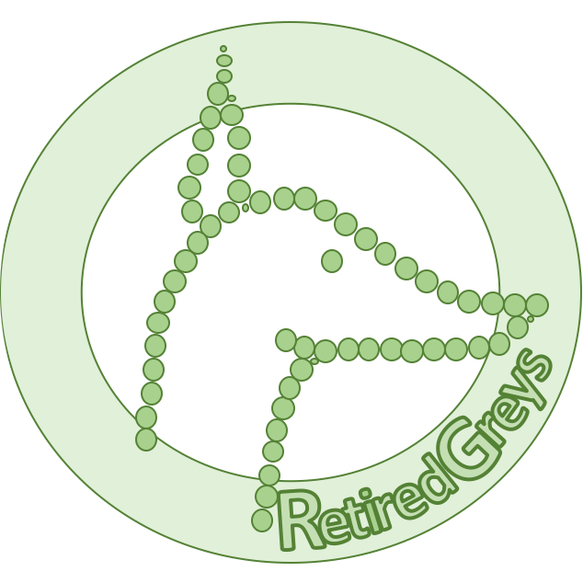
Send this form to the contact listed for the details of this Greyhound. Do Not send this form to Retired Greys.

Tell us a about yourself, your family, and your current pets.

What is your main reason for enquiring about this Greyhound today.

What is a definite yes/no requirement for this Greyhound.
Who are you interested to know more about?

Kennel Name: __________________________
Listing Number: ________________________
State: __________

Your Name: __________________________
Street:
___________________________
Suburb:
__________________________
State / Postcode:
_______ / __ __ __ __
Mobile: ___________________________

Valid email address

Forms to be Attached.
- Copy of your Drivers Licence*
- Photograph of your house
- Photograph of your back yard.

* Please cover your licence Card number.
Google Map shots not acceptable.

Retired Greys Inc. only provides a web platform for advertisement. All contact is directed back to the person who has custody of the Greyhound.
If you experience any difficulties during this process, please contact us immediately.

